Mid-Semester Examination
CS-3005 Solution Scheme
- Short Questions [ 1 × 5 ]
  - At the end of a memory read operation, the MDR is loaded with a binary combination, how that combination is interpreted as an instruction or an operand to an instruction?

Ans: If the memory operation is initiated by sending the contents of PC to MAR, then the content of MDR will be interpreted as an instruction else as an operand.
  - The content of register R1 is 1011001100110011.Write the instruction for performing the following operations:
                - Clear the LSB of R1 to 0.

AND #FF00H,R1
                - Set the MSB of R1 to 1.

OR #FF00H,R1
  - The content of register R1is 11010110. What will be the decimal value after execution of
RotateL #2, R1. [Assume the number is represented in 2's complement format]

After rotation R1’s content will be 01011011
In Decimal the value will be 155.
  - “Hardwired Control Unit is relatively inflexible”-Justify the statement.

When one new instruction is added in a processor having Hardwired CU, all the circuits involving the control signal present in the control sequence for the newly added instruction has to be changed.
  - A CPU has only three instructions I1, I2 and I3, which use the following signals in time steps T1-T5:
I1:  T1:A_{in},B_{out},Cin  T2:PC_{out},B_{in}  T3:Z_{out},A_{in}  T4:B_{in},C_{out}  T5:End | I2:  T1:C_{in},B_{out},D_{in}  T2:A_{out},B_{in}  T3:Z_{out},A_{in}  T4:B_{in},C_{out}  T5:End | I3:  T1:D_{in},A_{out}  T2:A_{in},B_{out}  T3:Z_{out},A_{in}  T4:D_{out},A_{in}  T5:End

Write the logic function for generating the signal A_{in}?

A_{in}=T3+I1.T1+I3.T4

- Write a program to evaluate the given arithmetic expression :- Prof. Himanshu Das [5]
Z = ( R + P ) * E + K * B - L / G - S
    - Using a general register computer with two address and three address instructions.
    - Using an accumulator type computer with one address instructions.
    - Using a stack organized computer with zero-address operation instructions.
    - Using RISC computer instruction format.
ANS:
- 3 Address Instructions:-

ADD R, P, R1
MUL R1, E, R2
MUL K, B, R3
ADD R2, R3, R4
DIV L, G, R5
SUB R4, R5, R6
SUB R6, S, Z

- 2 Address Instructions:-

MOV P, R1
ADD R, R1
MUL E, R1
MOV B, R2
MUL K, R2
ADD R1, R2
MOV G, R3
DIV L, R3
SUB R2, R3
MOV S, R4
SUB R3, R4
MOV R4, Z

- 1 Address Instructions:-

LOAD P
ADD R
MUL E
STORE X
LOAD B
MUL K
ADD X
STORE Y
LOAD G
DIV L
SUB Y
STORE W
LOAD S
SUB W
STORE Z

- 0 Address Instructions:-

PUSH R
PUSH P
ADD
PUSH E
MUL
PUSH K
PUSH B
MUL
ADD
PUSH L
PUSH G
DIV
SUB
PUSH S
SUB
POP

- RISC Instructions:-

LOAD R, R1
LOAD P, R2
LOAD E, R4
LOAD K, R6
LOAD B, R7
LOAD L, R10
LOAD G, R11
LOAD S, R14
ADD R1, R2, R3
MUL R3, R4, R5
MUL R6, R7, R8
ADD R5, R8, R9
DIV R10, R11, R12
SUB R9, R12, R13
SUB R13, R14, R15
STORE R15, Z

- [ 2.5+2.5]
- Explain the basic operational concept involved in the execution of an instruction with an example.
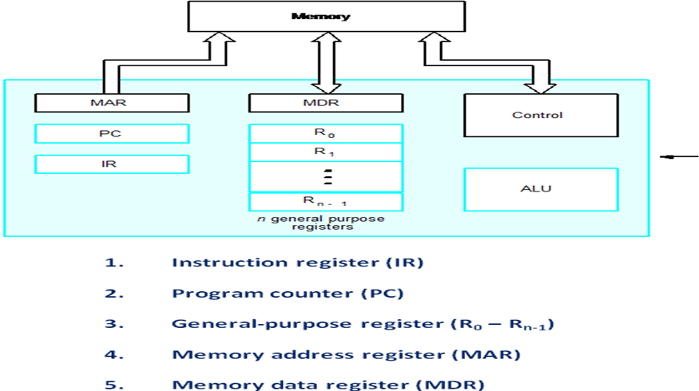
Typical Operating Steps
- Programs reside in the memory through input devices
- PC is set to point to the first instruction
- The contents of PC are transferred to MAR ( keeps address of the instruction in memory)
- A Read signal is sent to the memory
- The first instruction is read out and loaded into MDR
- The contents of MDR are transferred to IR (Instruction Fetch :- Add R1, R0)
- Decode and execute the instruction
- Get operands for ALU
  - General-purpose register ([R1],[ R0])
  - Memory (address to MAR – Read – MDR to ALU)
- Perform operation in ALU ( [R1]--> [R1] + [ R0]
- Store the result back
  - To general-purpose register ([R1])
  - To memory (address to MAR, result to MDR – Write)
- During the execution, PC is incremented to the next instruction.

- Give two examples from each of the following type of computer instructions, explaining their functions :-
[i] Data Transfer Operation [ ii] Logical Shift Operation [iii] Program Control Operation.

Data Transfer Operation
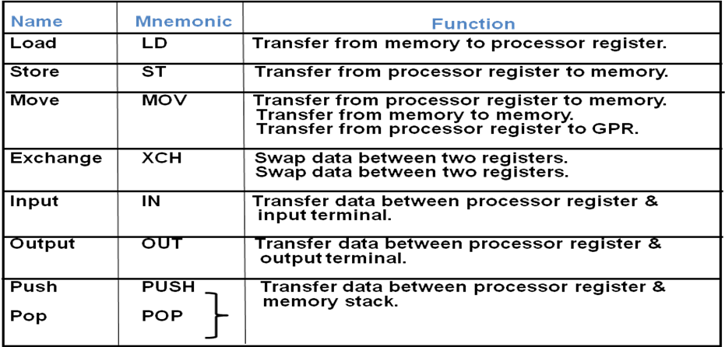

- Logical Shift Operation
LOGICAL SHIFT OPERATION
- Insert 0 to the end bit position, if the end bit position is left most then it is a right shift operation & if the end bit position is right most then it is a left shift operation.
- Example:-
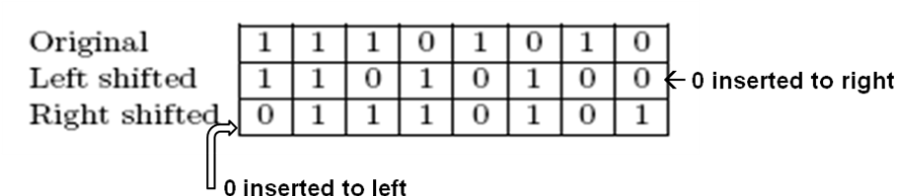

SHR #2, R1 and SHL #2, R2

Program Control Instructions
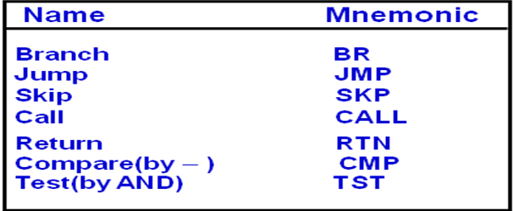

- [ 1+2+2]
  - How many times a subroutine should be called so that the stack becomes full, Assume that the stack address space ranges from 2000 to 1600 and each stack word consumes 4 bytes and machine is byte addressable.[Note: No parameter, return value, registers, local variables are stored in the stack due to subroutine call]
Ans:100
  - Match columns:
A B
Indirect Relocatable code
Index Passing array as a parameter
Base Register Array
Auto increment while (*A++)
  - Write the sequence of control steps for the following instructions for single bus CPU organization
Add (R3), R1.
The processor is driven by a continuously running clock, such that each control step is 2 ns in duration. How long will the processor have to wait in step2 and 5, assuming that a memory read operation takes 16ns to complete? What percentage of time is the processor idle during execution of this instruction?
Answer:1mark for control steps+1 mark for calculation
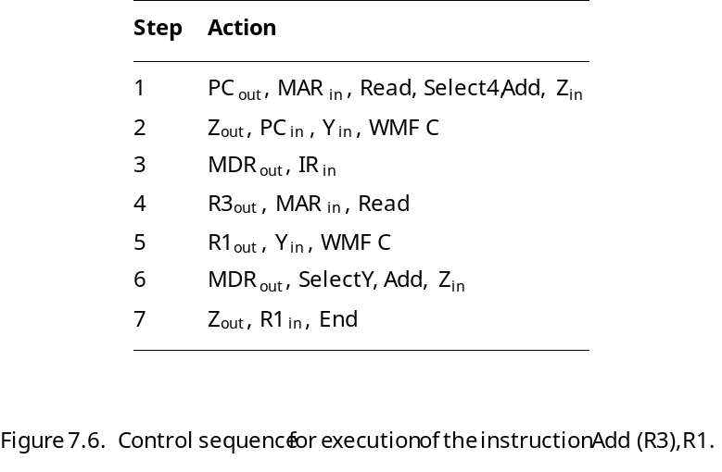
Following the timing model of steps 2 and 5 take 16 ns each. Hence, the 7-step sequence takes 42 ns to complete, and the

processor is idle 28/42 = 67% of the time.
- Prof.A.K.Aacharya [2+3]
  - Explain the working principle of micro-programmed control unit design with neat diagram.
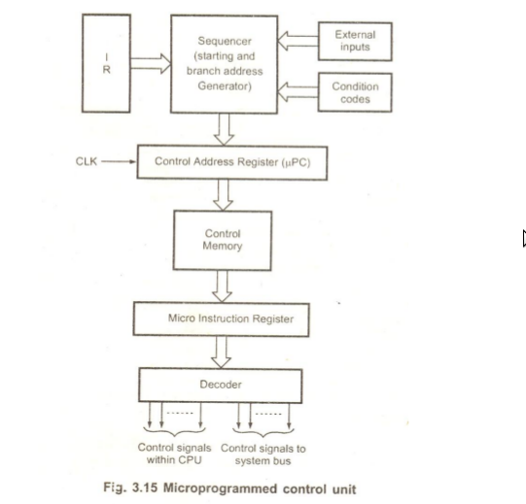
  - Given the following program fragment
Main Program First Subroutine Second Subroutine
2000 ADD R1, R2 3000 SUB1 MOV R1,R2 4000 SUB2 SUB R6, R1
2004 XOR R3, R4 3004 ADD R5, R1 4008 XOR R1, R5
2008 CALL SUB1 3008 CALL SUB2 4012 RETURN
1012 SUB R4, R5 3012 RETURN
1 mark for diagram + 1.5 for the explanation.
Initially the stack pointer SP contains 5000.
What are the content of PC, SP, and the top of the stack?
      - After the subroutine call instruction is executed in the main program?
      - After the subroutine call instruction is executed in the subroutine SUB1?
      - After the return from SUB2 subroutine?
Ans.i)PC=3000, SP=4996 ,St[top] = 2012
ii)PC=4000 SP=4992 st[top] =3012
iii)PC =3012 SP=4996, St[top]= 2012

- Prof. N. Panda [1+4]
- An instruction is a 24 bit instruction. It is a byte addressable memory. The PC contains 300. Which one of the following is a legal PC value:
        - 400 (b) 500 (c) 600 (d) 700
Ans:600
- Write the sequence of control steps for the following instructions for single bus CPU organization
- I1: ADD 10(R3), R4
Ans:
1. PC_{out}, MAR_{in}, Read, Select 4, Add, Z_{in}
2. Z_{out}, PC_{in,} Y_{in}, WMFC
3.MDR_{out}, IR_{in}
4. Offset field of IR_{out}, Y_{in}
5. R_{3out}, Select Y, Add, Z_{in}
6. Z_{out}, MAR_{in}, Read
7. R_{4out}, Y_{in}, WMFC
8. MDR_{out}, Select Y, Add, Z_{in}
9. Z_{out}, R_{4in}, end
- I2: Branch<0 L1
Ans:
1. PC_{out}, MAR_{in}, Read, Select 4, Add, Z_{in}
2. Z_{out}, PC_{in}, Y_{in,} WMFC
3. MDR_{out}, IR_{in}
4. offset field of IR_{out}, Select Y, Add, Z_{in}if N=0 then end
5. Z_{out}, PC_{in}, end

- I3: MUL -(R5), R5
Ans:
1. PC_{out}, MAR_{in}, Read, Select 4, Add, Z_{in}
2. Z_{out}, PC_{in}, Y_{in}, WMFC
3. MDR_{out}, IR_{in}
4. R_{5out}, Select 4, Sub, Z_{in}
5. Z_{out}, R_{5in}, MAR_{in}, Read
6. R_{5out}, Y_{in}, WMFC
7. MDR_{out}, Select Y, MUL, Z_{in}
8. Z_{out}, R_{5in}, end
- Design the logic function for WMFC control signal with reference to the above instructions i.e. I1 to I3.
Ans:WMFC = T₂ + Add . T₇ + MUL . T₆

